Accompanying teaching notes for KS1 fire safety lesson

Suggested questions

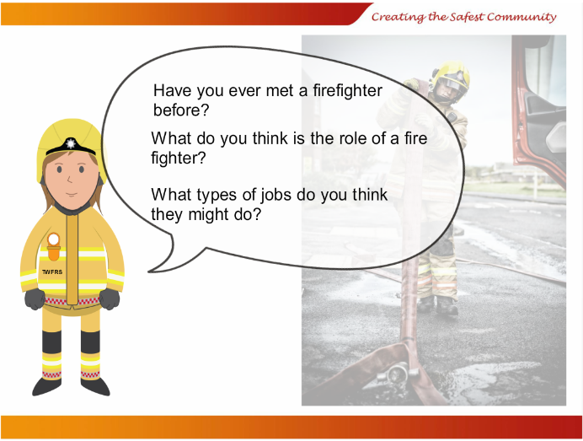Discussion points 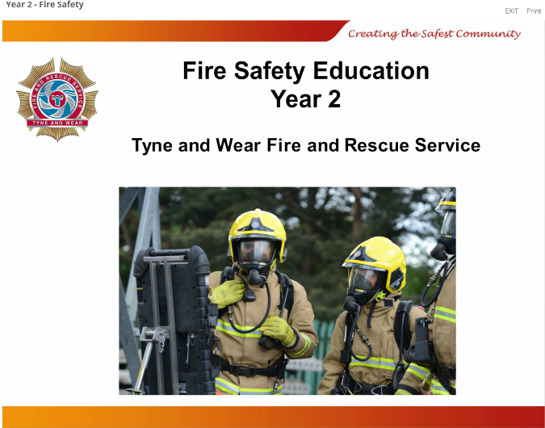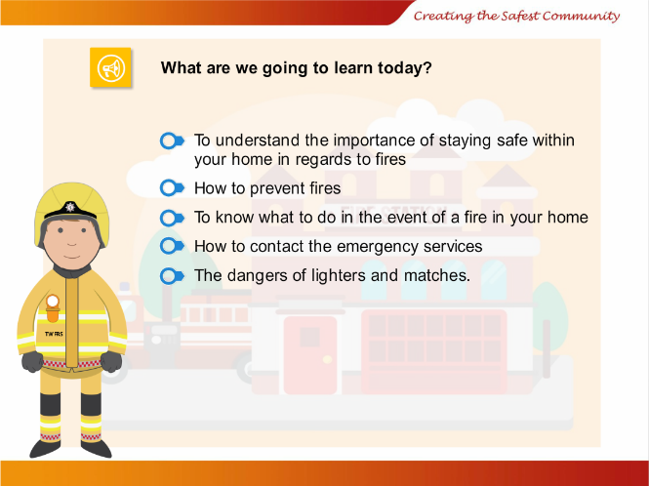

Slide 3

The role of a fire fighter

Has anyone met a firefighter?

Discuss what types of jobs you think a fire fighter might do (put out fires, give safety advice, and attend road accidents)

Slide 1

An introduction to the lesson by Karen Soady

Slide 2

Lesson objectives

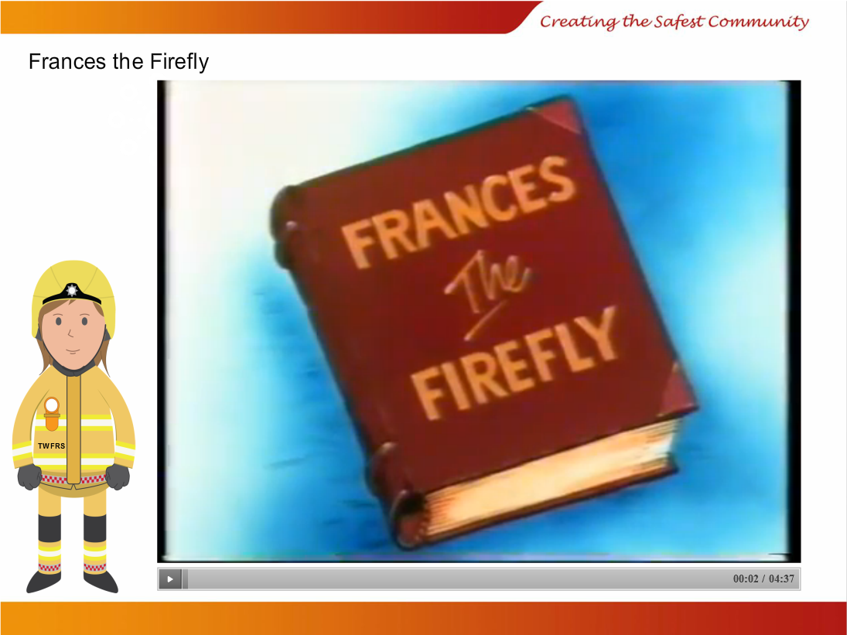

Slide 3

Lighters and matches

This slide contains a short cartoon about the dangers of matches.

Stop the video at the point in which the cockroach gives Francis a match and discuss why matches are dangerous and what could happen. Then play the remainder and discuss what happened.

What did Francis do? What happened to the village?

Why is fire dangerous? What could happen if we played with matches?

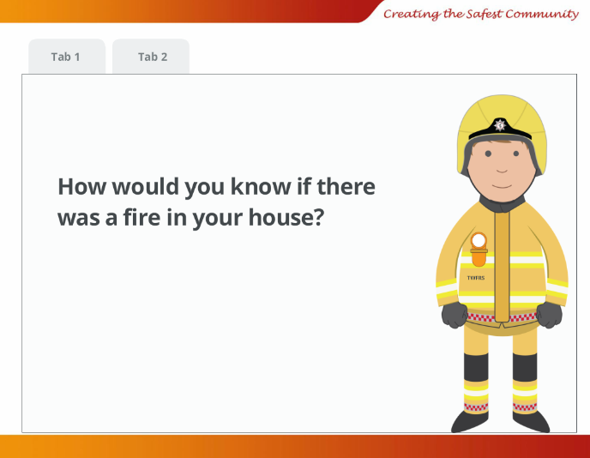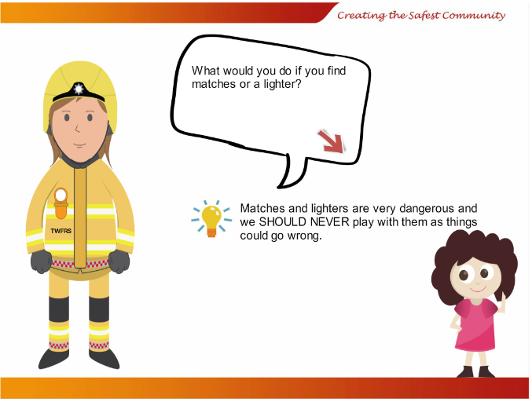

Slide 5- has 2 tabs

How would you know if there was a fire in your house?

See smoke – see the fire – hear the fire

Slide 4

Lighters and matches

What should you do if you find lighters or matchers? (Leave them alone and tell an adult)

Go over how dangerous they are and what happened to Francis

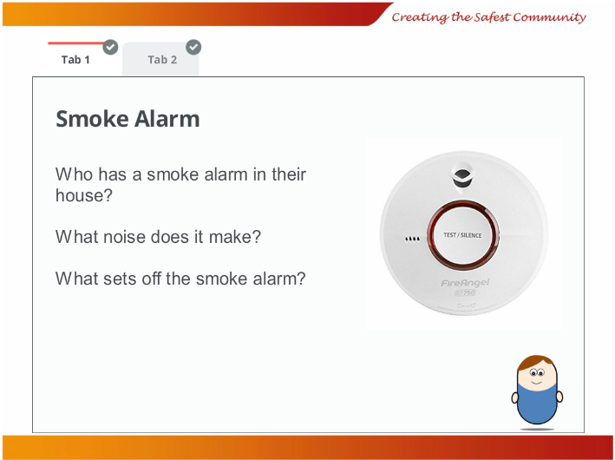

Slide 5 Tab 1

If there is a fire your smoke alarm will sound

Where will your smoke alarm be?

Why does it need to be on the ceiling? (as smoke rises up)

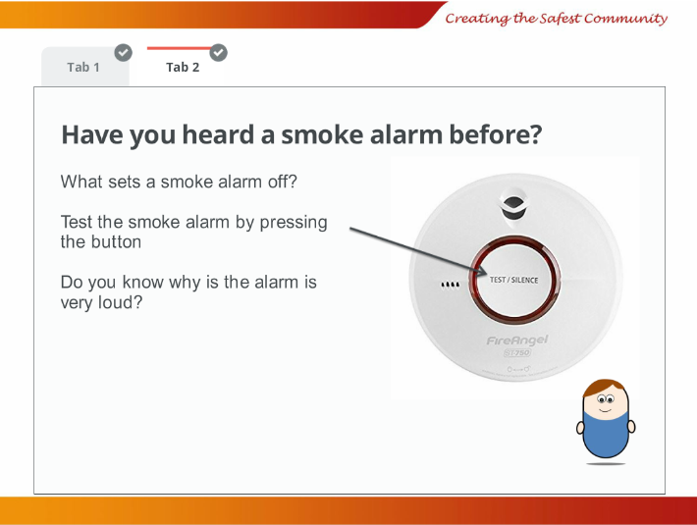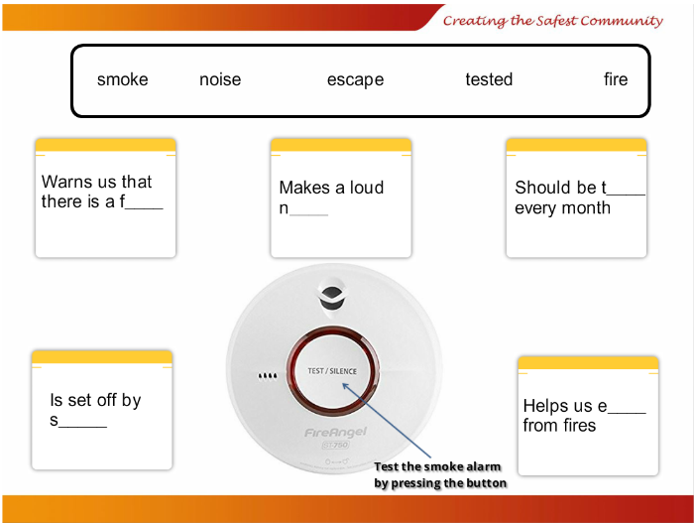

Slide 5 Tab 2

How do you know if your smoke alarm works?

(Apart from it going off in a fire it needs to be tested)

It should be tested every month

Clicking on the smoke alarm will make the alarm sound

Slide 6

Smoke alarm quiz

